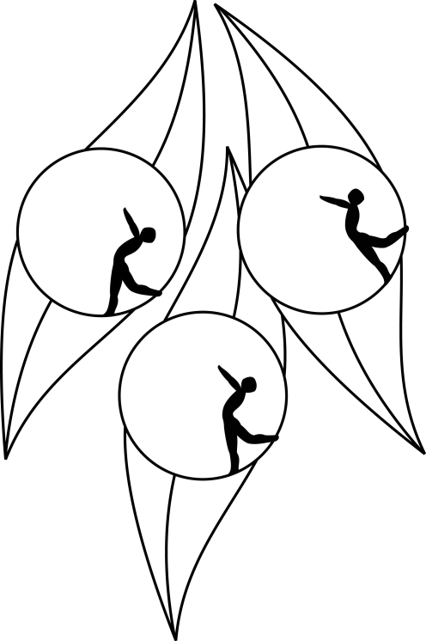
SOUTH AUSTRALIAN ICE SKATING ASSOCIATION Inc.

RESULTS

TEST SESSION

1 October 2009
Ice Arena, Thebarton

Congratulations to the following skaters:

Junior:
Melissa Tyson
Novice
Amy Newbery
Hannah Smith
Samantha Zerella
Primary
Katrina Norwood
Elementary 2:
Bianca Martin
Elementary 2 Technical:
Amelia Davis
India Nette
Katie Rattigan
Elementary 1 Technical:
Giuseppe Triulcio
Preliminary:
Angela Berry
Raelene Berry

